*This quick lesson assumes you have already created your divs for your website. Use your notes from “****Creating a CSS Rule”*** *(Assignment 4-2) and “****Positioning with a Div****.” (assignment 5-1)*

**Placing a picture**

1. Make sure you are in the _____ appropriate div (especially in the code) _______________
   1. 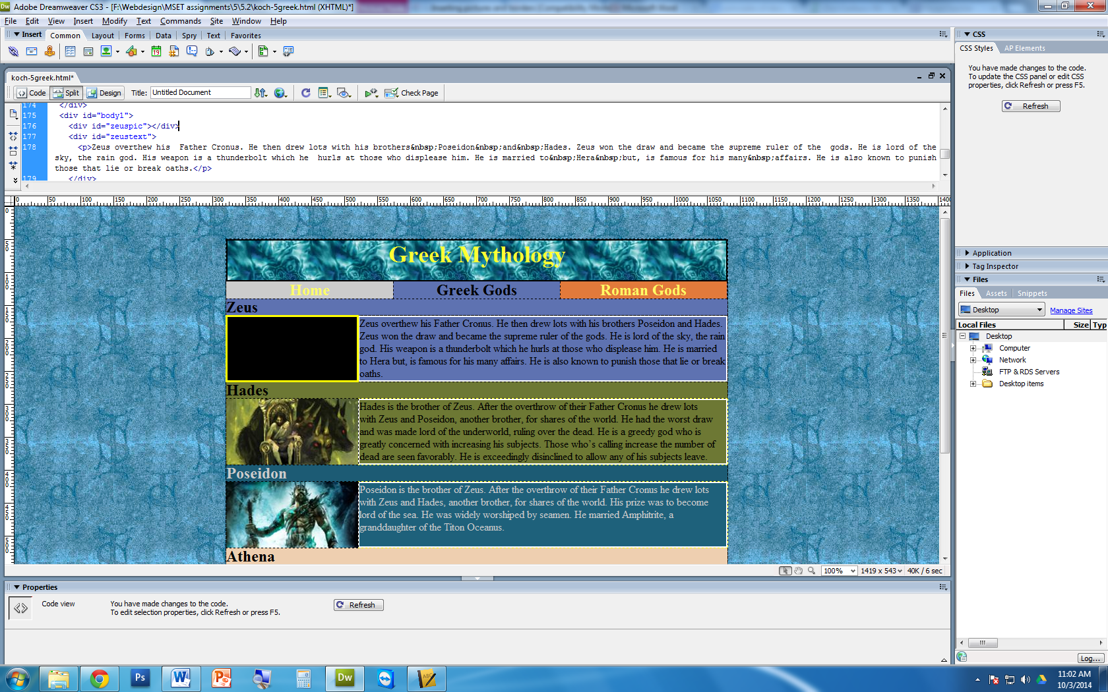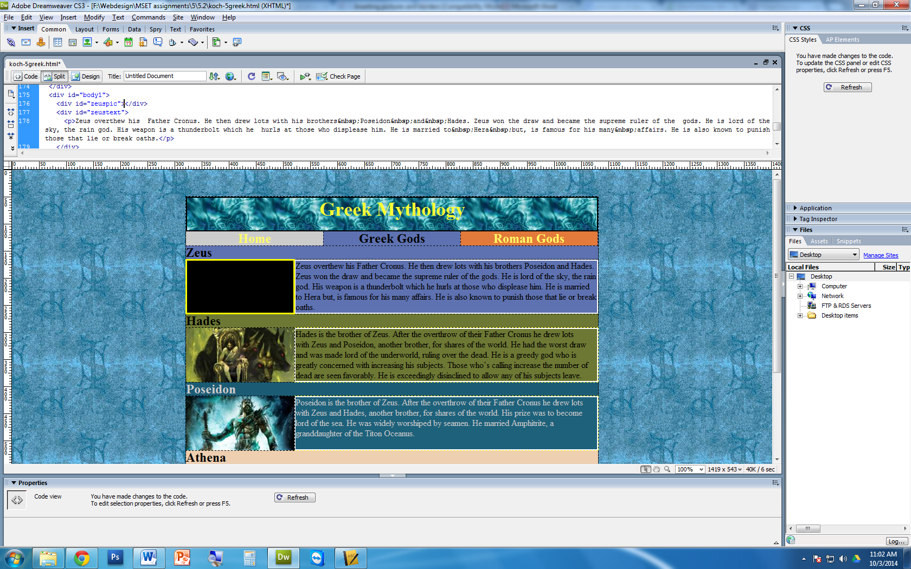 (circle the correct picture)
2. 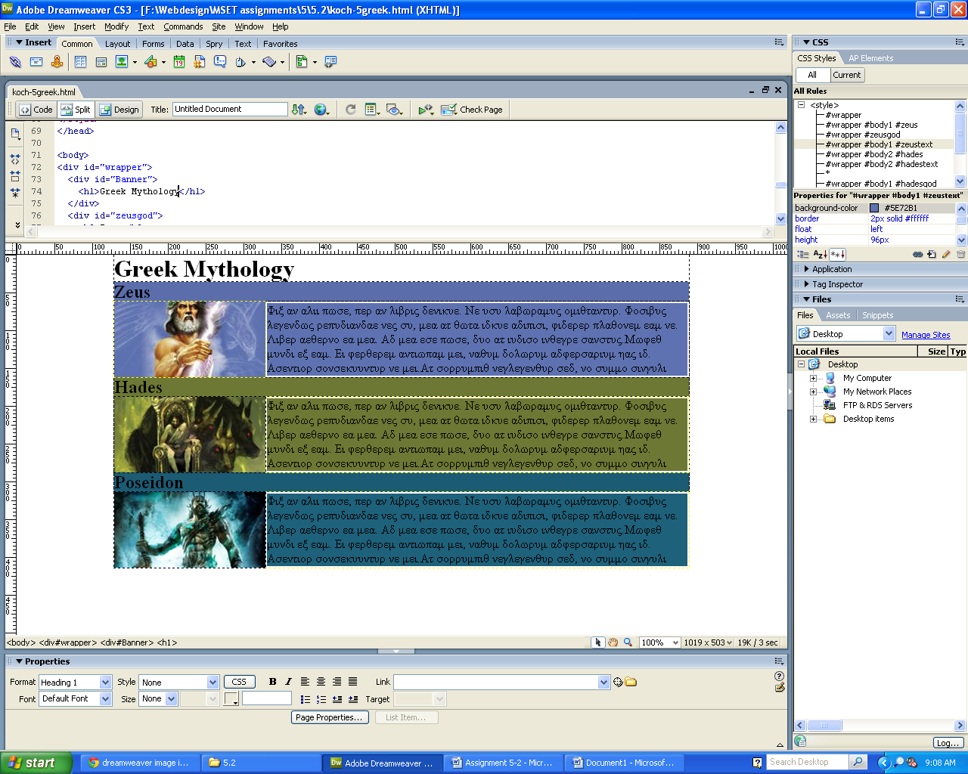Click on the   
   image icon
3. Locate your picture. Make sure your pictures are__saved in the right root folder__________
   1. If not, what will happen when you place it on the T: Drive?  
      the pictures will not show up when I (mr. Koch) checks it on the T drive
   2. Add alternate text

**Adding a border through CSS Rules (for assignment 5.2)**

*In your* ***CSS rules****, we need to change a few things. Double click on your CSS Rule in your CSS window.*

1. In the _______ BORDER _____________ tab
   1. Create the style. (same for all)
      1. Create the ______ WIDTH _____. We will use __2___ for this assignment
   2. Create the color. (same for all)
2. What happens to the div?   
   BORDER AROUND the text, the div got bigger (by 2 pixels on each side)
3. In the _______ box __________ tab
   1. Change the height and width
      1. **MATH QUESTION:** If we have a width of 2 pixels on each side of our div, how much do we have to reduce the height and width?   
          Answer: __4___ x __4____
   2. What is the height and width of our div **without** the border?__ 560__x__100___
   3. What is the final height and width of our div **with** the border? __556__x__96___
      1. This is the height and width we have to adjust in the CSS rules